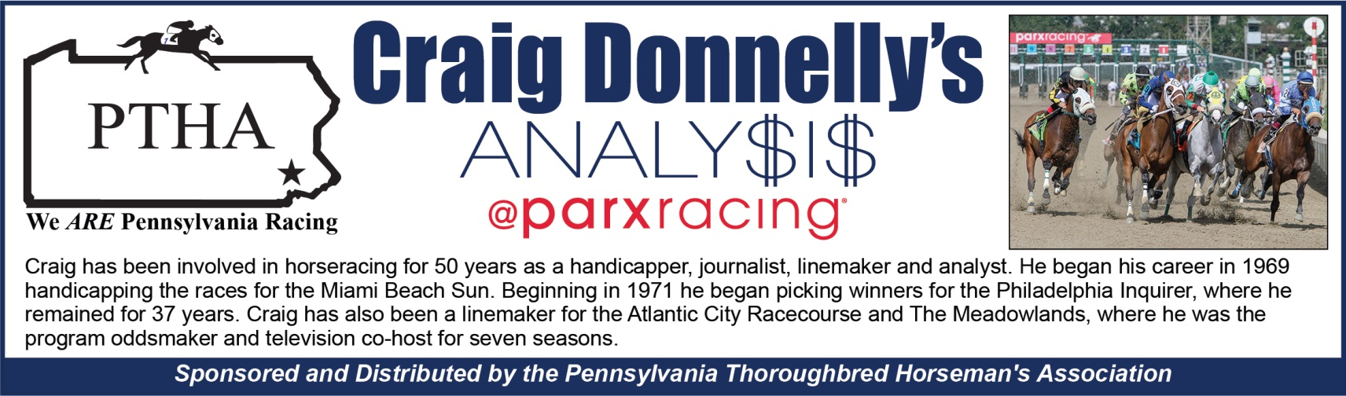
MONDAY, JULY 6, 2020—FIRST POST 12:55 P.M.
Best Bets: ROL AGAIN QUESTION (6th)-- MINISTER’S STRIKE (7th)
Race 1
 | BETTER BEGIN – Numerous good efforts with better in Gulfstream turf routes; hinted at main track prowess.
 | SYMPHONY OF LOVE – Dueled eventual winner to late stages in return; should progress but 15 defeats.
e | RUSSIAN MELODY – Speedy elsewhere but stamina issues; lightly raced at four different venues.
 | STORM BABE – Contributes to lively fractions but sidelined over year with 13 chances.
Race 2
 | ARRECIFE – Overmatched in sprint after layoff and huge effort despite brutal trip here in January.
 | BOSS OF BOURBON ST – Battled solid group in March and edged despite stumbling start previously.
 | HEART OF A DREAMER – Handled lesser over track and benefit of recent exercise; seeks third in row.
 | KAIROS – Soundly beaten by second pick when Pino claimed in winter offers closing kick on occasion.
Race 3
 | SHANGHAI SUPERFLY – Failed in classier company after hiatus and appears favorable pace scenario.
 | TALENTED SON – Absent since November but won last two local attempts prior to Penn National loss.
 | TALLY MO – Speedy and capable with several frustrating defeats including disqualification; early pressure.
 | WILL’S PIONEER – Always reaches front early and idle since rare poor showing; shorter yardage some relief.
Race 4
 | VERO SUN – Chased runaway winner in bulky field at Belmont after layoff; best of experienced runners.
 | AFLEET MELODY – Dueled throughout and victim of trouble in stretch; chance with similar showing.
 | COAST TO COAST – Dull in return as odds-on favorite and also failed at 1-2 in Md.; can’t dismiss yet.
 | EL FENOMENO – Flashes of interest in nine outings and deserves second look adding blinkers.
www.patha.org
Race 5
DEE JAY – Sire was multiple graded stakes-winner on turf with over $1 million in bank; adding Lasix.
SUPER DANCER – Improved since trying blinkers at Laurel and successful sire won 2010 Ky. Derby.
SPIDER BITE – Just over three lengths behind as longshot in turf bow and extra distance might help.
UNCOMMON VALOR – Dull against quick group in only second start; changes surface and yardage.
Race 6
ROL AGAIN QUESTION – Versatile veteran won pair at Tampa and perfect in three local attempts over years.
FIX ME A SANDWICH – Re-claimed by Taylor barn where he achieved ample success in past; comes out flying.
POPIZAR – Powerful stretch-runner comes off freshener with ample targets; Vega barn won last two features.
DEAL DRIVEN – Speedy router idle since impressive November romp; adjust to sprint in return.
Race 7
MINISTER’S STRIKE – Overcame wide trip despite nine month’s absence at Laurel; 9-for-25 on turf lifetime.
TRILOGY – Turf pro competed only once since December but consistently fires over this course.
K D’S CAT BIRD – Should benefit from return to turf where he won stake at Colonial last year; slow fuse.
MACHTREE – Roughed early before fading after layoff; all three victories over turf.
Race 8
WORD ON A WING – Terrific form while lightly raced with six starts; finished on top four times by wide margins.
FORT FORTITUDE – Pressed pace and continued willingly on turf at Belmont; Ness barn winning everywhere.
BUDDY’S RUN – Hard-earned score with slightly lesser at Laurel; must consider all Gonzalez runners.
ROOKIE SALSA – Perfect twice since claim and upset stake at Churchill as juvenile; idle since February.
Race 9
SON OF DARKNESS – Excellent speed but caught late when trying Lasix and blinkers; gelded for return.
INSPIRING JUSTICE – Chased top pick over muddy footing and just missed previously; serious contender.
MT SURIBACHI – Made up ground too late but advantage of recent exercise; may stalk pacesetters.
STAR LUCK – Vied to mid-stretch before weakening after hiatus; fitter now but severe early pressure.

